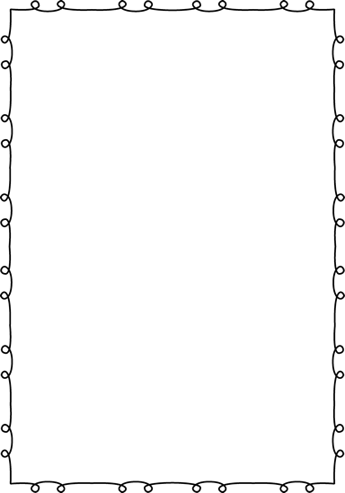

**Kindergarten Supply List**

Welcome to Kindergarten at Verdi Elementary!

The following supplies will be helpful and appreciated:

* 1 pencil box
* 12 pencils (Ticonderoga brand recommended)
* 1 pair of child size scissors (Fiskars brand recommended)
* 2 boxes Crayola Crayons (24 count)
* Black Dry Erase Markers (Expo brand recommended)
* 1 (70 page) spiral notebook
* 1 folder (The sturdier, the better.)
* 10-15 gluesticks (We go through a lot of these in Kindergarten!)
* Backpack (No wheels, please.)
* 1 box of Ziplock Baggies (Last names starting with A-M, please bring sandwich size, and last names starting with N-Z, please bring gallon size.)
* $25 Class Project Fee- Checks can be made out to Verdi Elementary School. Monies collected will go into a classroom account and will pay for special project supplies, science experiments, photo developing, classroom incentives and Scholastic News Magazine.

Please try to bring all supplies to your child’s Kindergarten Screening appointment. If your family has trouble providing any of the above items, please let me know and I will be happy to help!

Thanks so much!

Mrs. McKemy and Mrs. Peterson